

Swiggy Data Analysis



Wireframe Documentation

Tarana Parween

Analysis

As per the problem statement, we have defined the several Use Cases to perform the analysis on which helps in not only understanding the meaningful relationships between attributes but it also allows us to do our own research and come-up with our findings.

# Distribution of 'Rating':

In this DistPlot visual, we tried to interpret the distribution of Ratings.

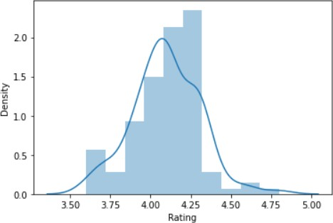

# Area-wise Analysis on ‘Rating’ and ‘Cost_for_Two (₹)’:

In this section, we analyse the data and tried to interpret the followings - I.e.

* **BTM Area:**

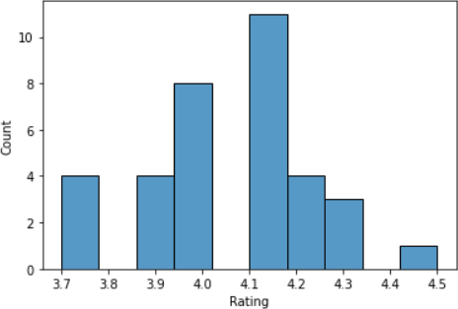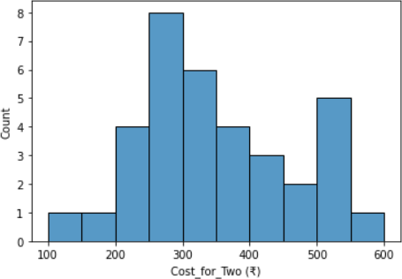

**BTM**: Most has **4.0** to **4.2** Rating and Approx. Cost for Two People lies between **200** to **350**. (Max. Cost goes upto **600**)

* **HSR Area:**

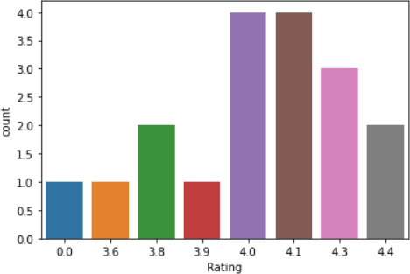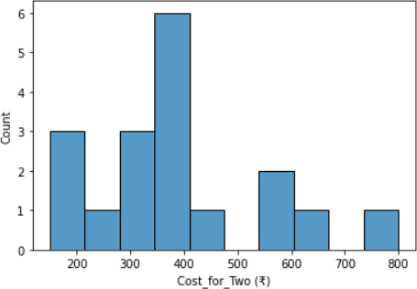

**HSR**: Most has **4** or above Rating and Approx. Cost for Two People lies between **300** to **400**. (Max. Cost goes upto **800**)

* 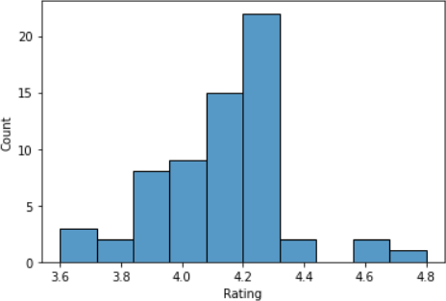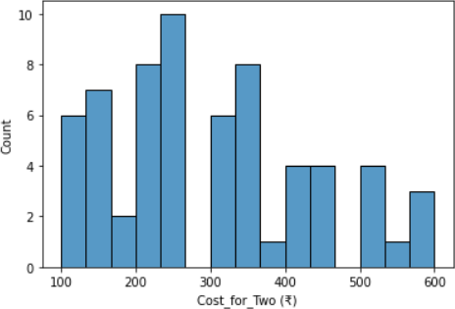**Koramangala Area:**

**Koramangala**: Most has **4.0** to **4.3** Rating and Approx. Cost for Two People lies between **200** to

**350**. (Max. Cost goes upto **600**)

With this we can conclude the Most Costly Area is **HSR**.

# Analyse "Approx Cost of 2 People" vs "Rating". Find out the relationship between them:

Here, we tried to interpret the relationship between "Approx Cost of 2 People" vs "Rating" using Scatter Plot.

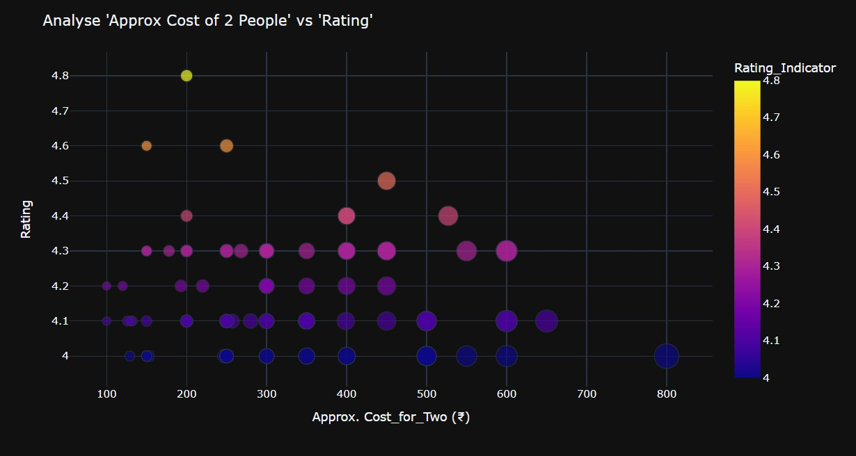

# Analyze Affordable/Budgeted and Highest Rated Restaurants of Bangalore:

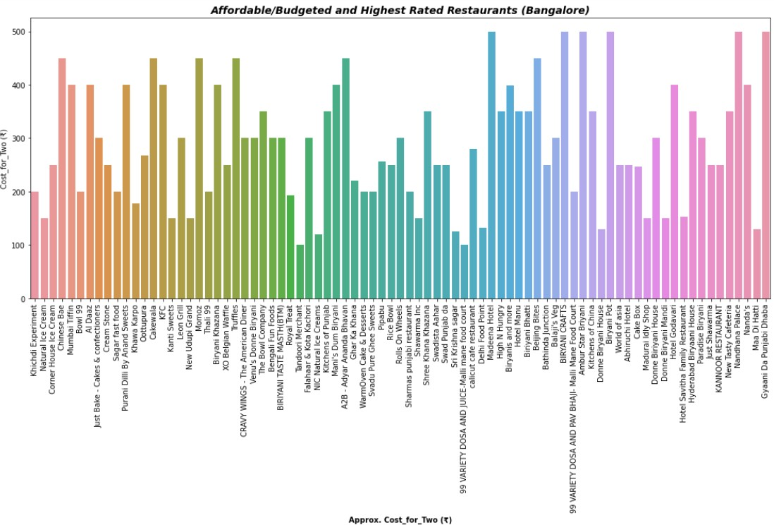

1. **Top 15 Cheapest & Highest Rated Restaurants with Approx. Cost for 2 People:**

Here, we tried to find-out the Cheapest and Highest Rated Restaurants with Approx. Cost of 2 People.

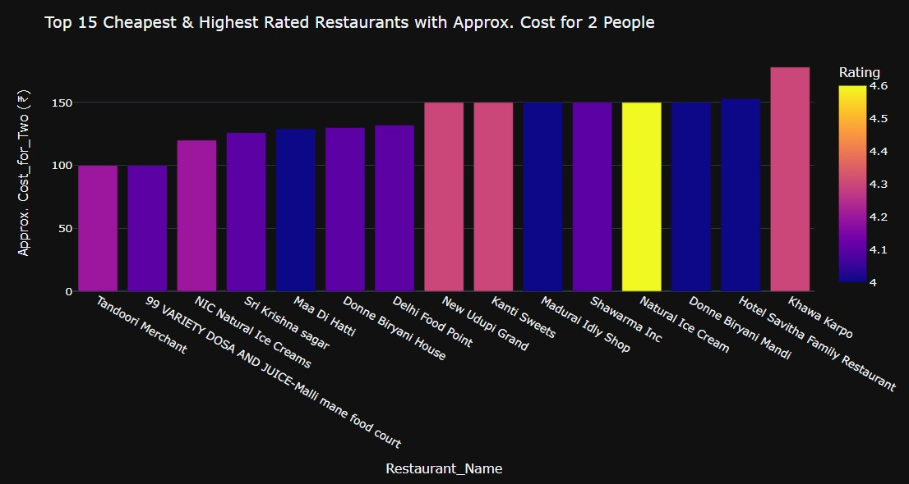

# Top 15 Expensive & Highest Rated Restaurants with Approx. Cost for 2 People:

Here, we tried to find-out the Expensive and Highest Rated Restaurants with Approx. Cost of 2 People.

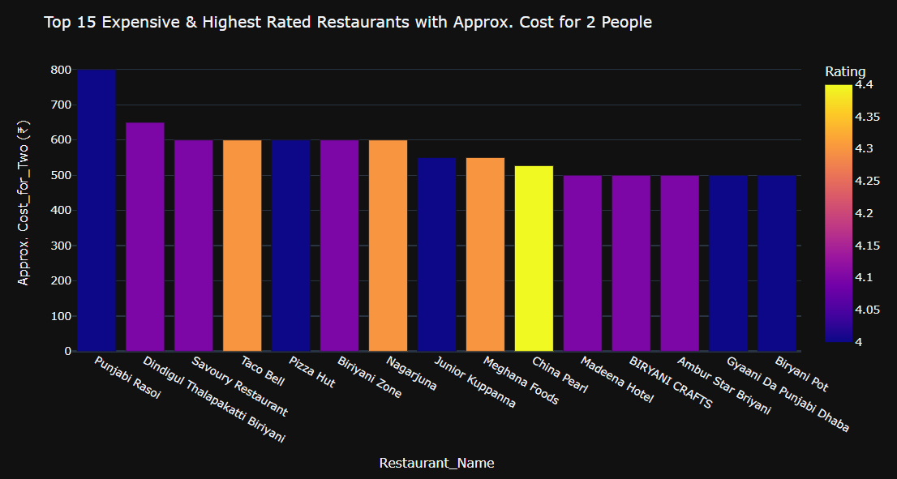

* **Cuisines Analysis:**

# Cuisines Overall Analysis (Bangalore)

Here, we tried to interpret the Most preferred Cuisine type in the entire Bangalore.

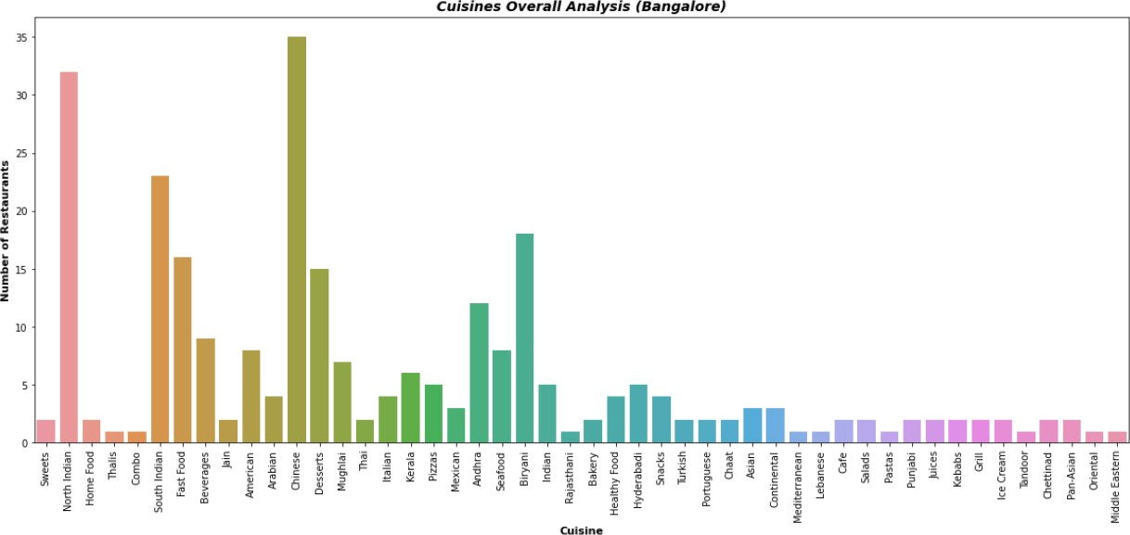

# Overall Distribution of Cuisines in Bangalore Restaurants:

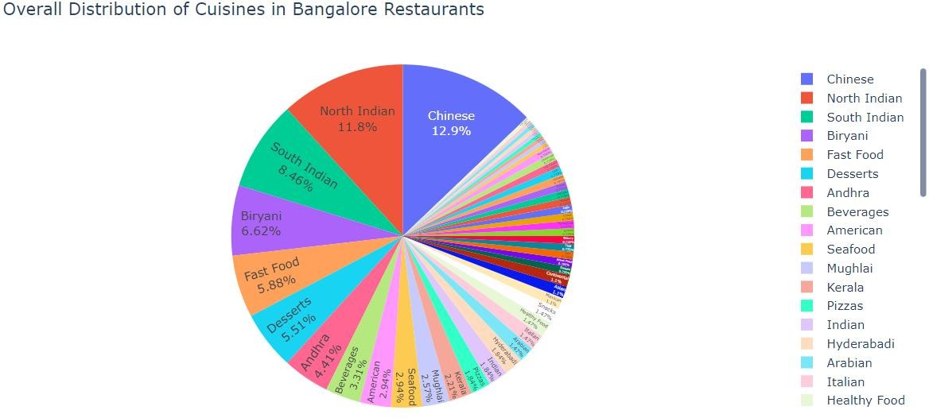

1. **Area-wise Cuisines Analysis:**

In this section, we analyse the data and tried to interpret the followings - I.e.

* **BTM Area:**

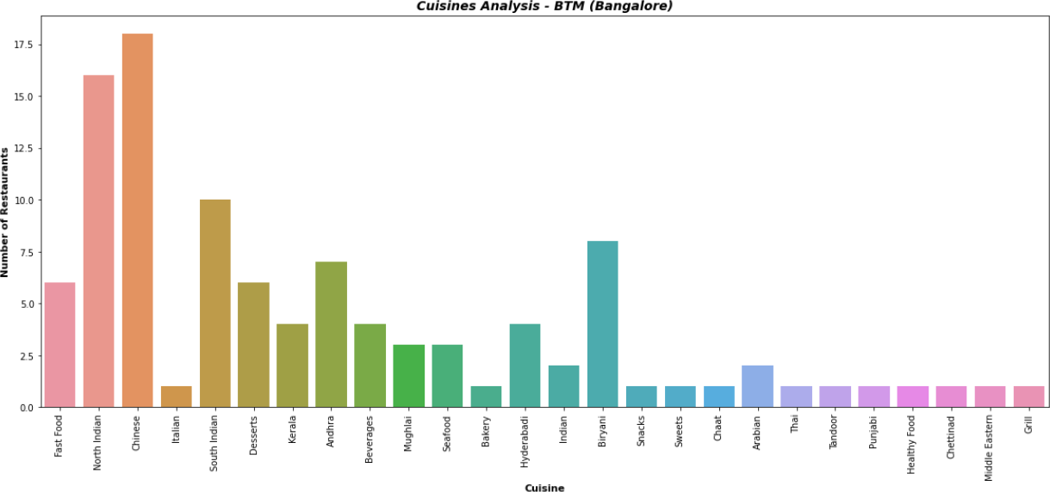

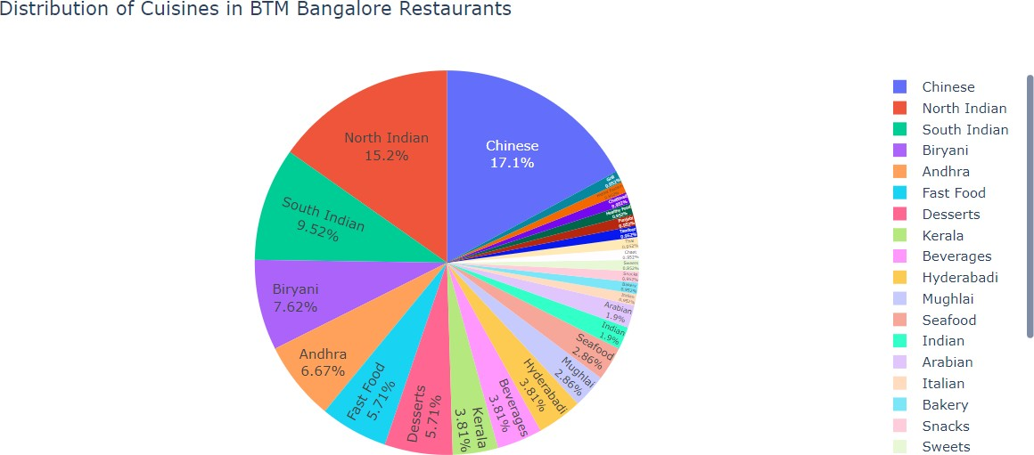

* In **BTM** Area, ***Most of the Restaurants*** sell **"Chinese"** which is around **'17.1%'** followed by **"North Indian"** & **"South Indian"** Cuisines which are around **'15.2%'** & **'9.52%'**.
* So, we can also infer that Most of the people are fond of these Cuisines.
* **HSR Area:**

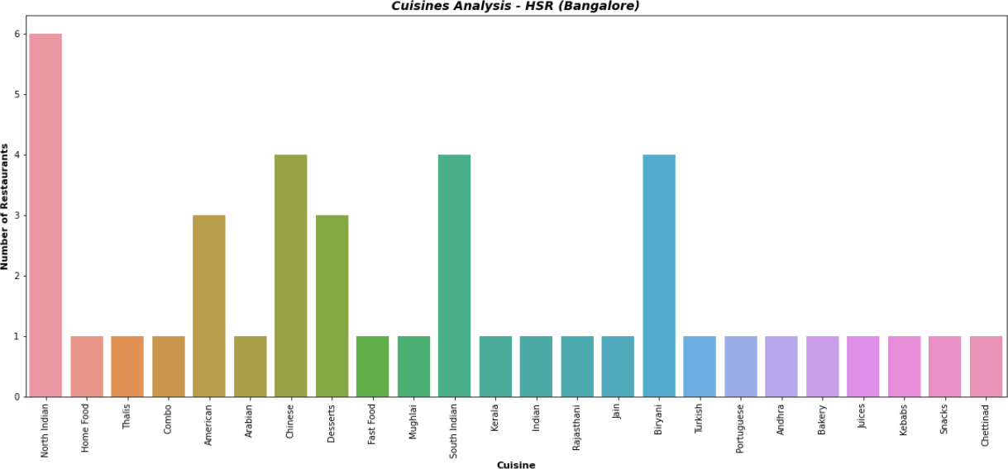

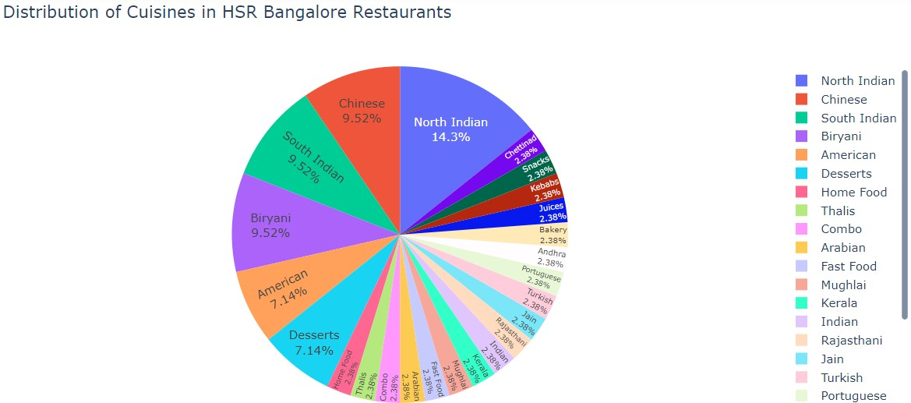

* In **HSR** Area, **"North Indian"** Cuisines are dominated by around **'14.3%'** followed by **"Chinese"** & **"South Indian"** Cuisines **'9.52%'** & **'9.52%'** Restaurants respectively.
* So, we can also infer that - In HSR Area, We may have more **"North Indian"** people staying there.
* **Koramangala Area:**

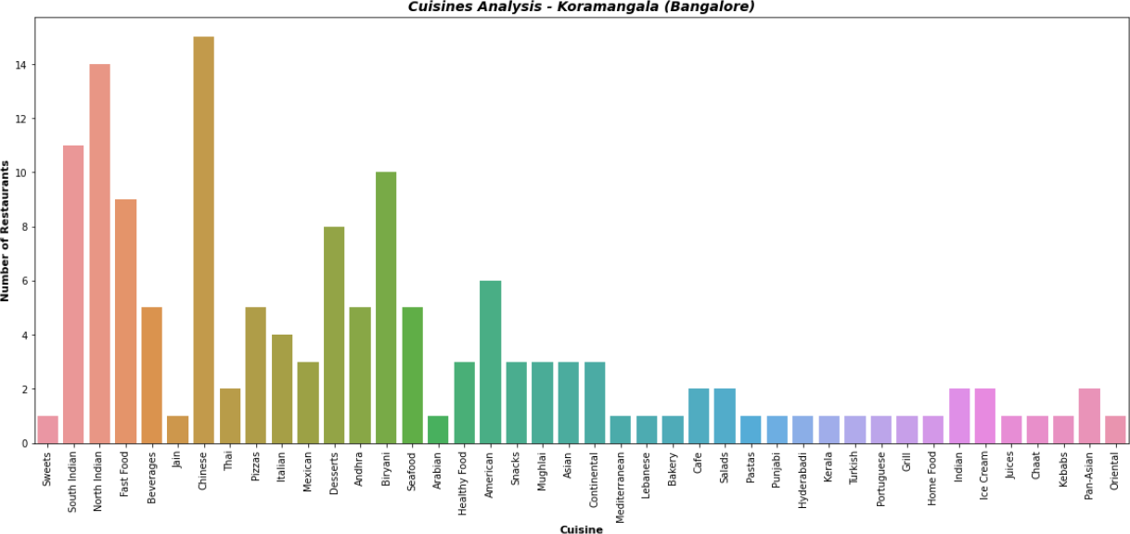

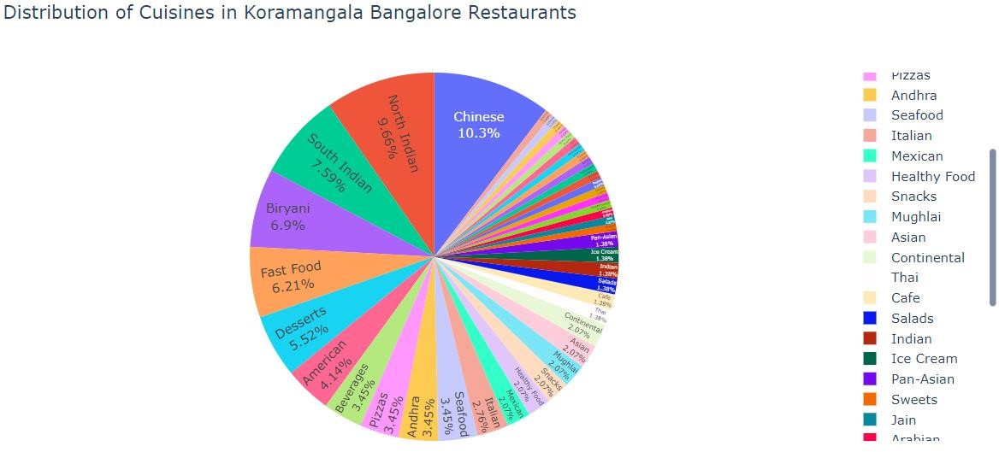

* In **Koramangala** Area, **"Chinese"** Cuisines are dominated by around **'10.3%'** followed by **"North Indian"** & **"South Indian"** Cuisines **'9.66%'** & **'7.59%'** Restaurants respectively.
* So, we can also infer that Most of the people are fond of the **"Chinese"** Cuisines.
* **WordCloud Representation for Cuisines:**

# Most preferred Cuisines by the Customers:

Here, we tried to interpret the Most preferred Cuisine type in the entire Bangalore using WordCloud.

